Week 12 Individual Logbook
Capstone project
Matt Baker
2026
Table of Contents
Hours Breakdown 2
Completed Content/Documentation 3
Team Meetings 3
Advisor Meetings 3
Client Meetings 3
Research 3
Documentation 3
Testing 5
Development 8

Hours Breakdown
Category | Hours completed
Team meetings
Client meetings
Advisor meetings
Research
Development
Testing
Documentation
Logbook preparation | 1hr
Sick leave/specific conditions
Other
Total Hours for this week
Running total of hours completed for  Capstone | 276hrs 30min/450hrs

Completed Content/Documentation

Team Meetings
Monday, September 28
12:15 – 12:45PM (30mins)
Meeting with all present, I explain to Sam what is needed in the flow charts that explain the process flow of my scripts, and reasons why humans should produce pdfs also modify and give Dave the higher quality original copy of the adapted DSR methodology diagram.
Tuesday, September 29
10:00AM – 12:00PM (2hrs)
Team meeting with all present, team logs, auditing, discussion on recent developments, quality of pdfs, what needs to be done for mid project review, what is expected by individuals (2 log examples + discussion) also the methodology (ERA) for giving discussion.
3:30 – 4:00PM (30mins)
Meeting with Olivia proofreading and making sure the mid project review satisfies the descriptor and is honest to our project’s development.
Advisor Meetings
Tuesday September 29
9:00-10:00AM (1hr)
Reporting to Bryce on progress in tshark csv conversion, printing of pdfs, increase in context length. Bryce shows us what we need to strip from the pcaps and base64 decoding tools.
Friday, Oct 2
9:00 – 11:00AM (2hr)
Meeting with Bryce with all present, we looked over some examples of project self-management reviews from other teams, how to approach this, had Bryce review our poster, general discussion on progress so far. We need more hours, but that we’re on track with hours generally.

Client Meetings

Research

Documentation
Wednesday, September 30
10:30AM – 1:00PM (2hrs 30 min)
Compiling a list of technical, logistical, and epistemological challenges the team faced with provisioning and integrating AI with digital forensics tools. Scouring my logbooks/documentation to find challenges I overcame and how that were forgotten. The purpose of this was to help improve the poster and build our findings.

This is what I produced in that time.
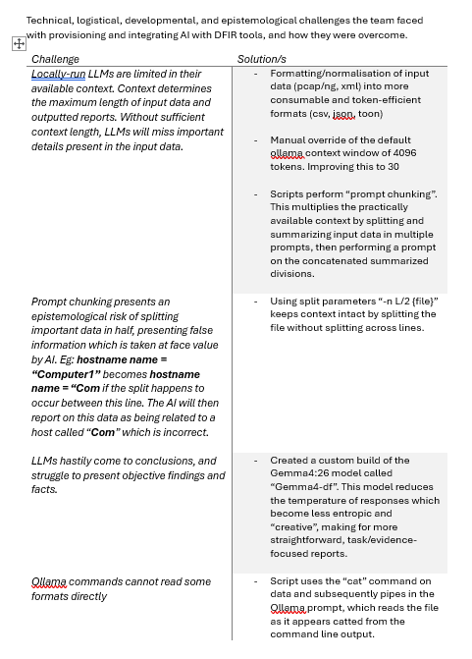

Thursday, October 1
4:30 – 7:00 (2hrs 30min)
Picking and writing a reflection of my individual evidence for the self-management review. This is the bulk of what I produced other than the pasted in parts of my logs as evidence in the appendices.
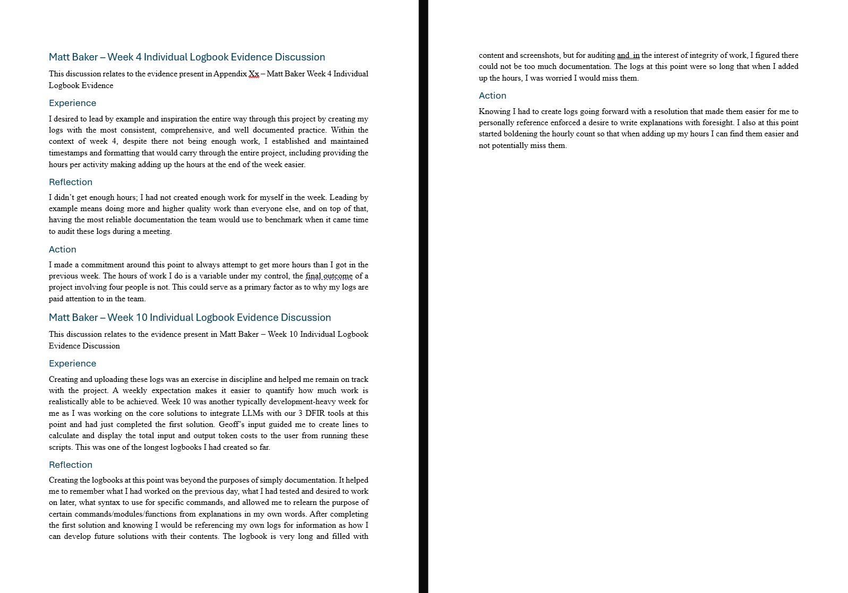

Testing
Monday, September 28
3:00 – 3:30PM (30 min)
Testing if I can convert pcaps to csv through the linux cli with “tshark”.
The command Bryce gave me (with some modifications) works.
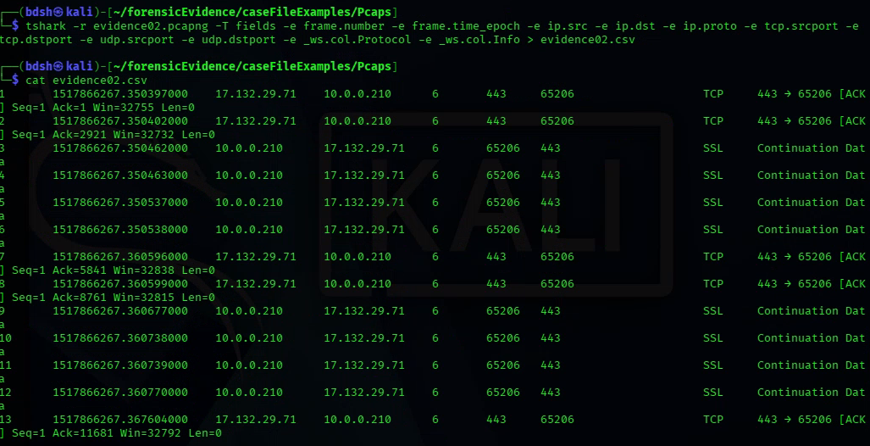
This means I can make Hammerhead V1 do this automatically through my script.
Wednesday, September 30
2:45 – 4:15PM (1hr 30 min)
Testing “toon-parse”, xml Nmap scans convert but their content shows little change, tested xml to json and to toon with 3 source xml files.
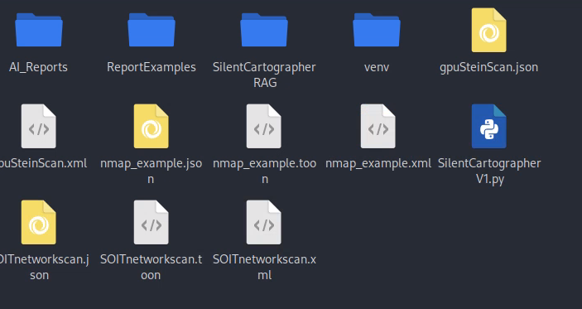
The word count and byte counts are slightly less, so some processing has happened
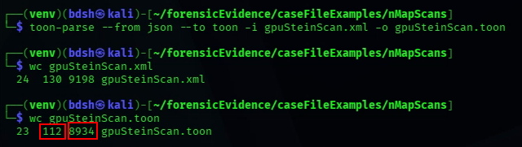
It appears to me however, that the core xml has not been modified, the <> syntax is still present
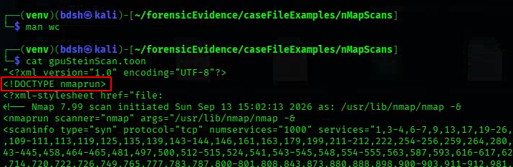
The effects are much more apparent on the larger Nmap scans.
The original xml of this large example is 64,135 bytes, 3601 words. (1)
Converted to .json it is 40,343 bytes 2923 words. (2)
Despite toon being supposedly more efficient than json, it reduces the file’s size by the same degree. (3). Because of this reduction, I am ok with using json or toon for this project.
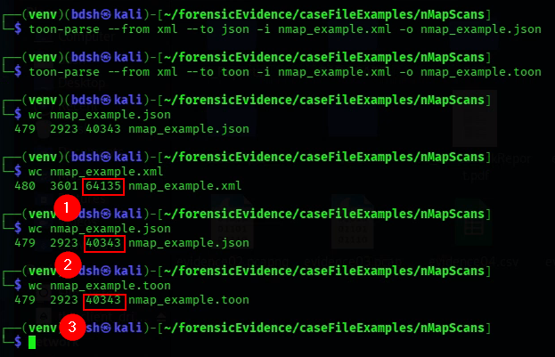
Also found out that ollama accepts input of .toon files and simultaneous output in the same prompt
This means I will not have to cat and pipe in this file.
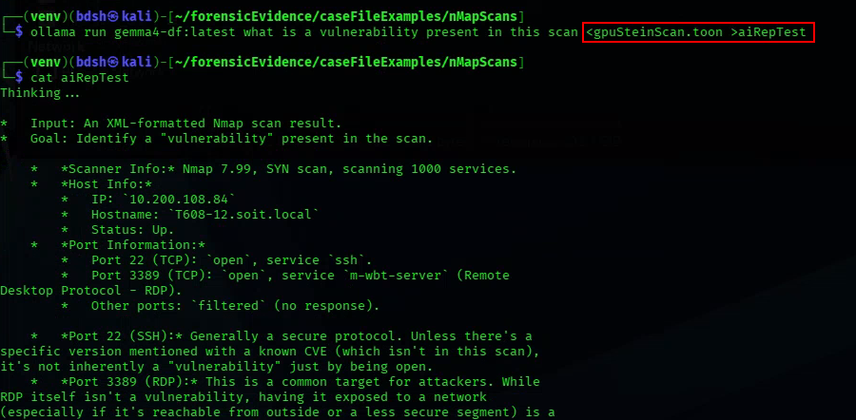

Development
Monday, September 28
3:30 – 6:00PM (2hrs 30 min)
Code creates a new variable with the suffix stripped off of the input file with re. (“evidence1.pcap” > “evidence1”). This lets us add the new csv to it when declaring and converting the file. It also doesn’t matter if the input file is pcap or pcapng, it just removes everything after “.”.
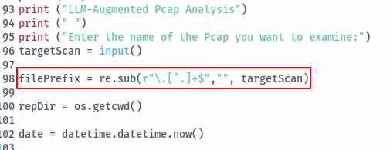
Previously tested tshark pcap>csv conversion used on the input file variable(1) in a shell subprocess.
Then the suffix-stripped file name is appended with “.csv” to complete its final name (2).
To which then the main chunking command will further process.
Also converted all .txt generated from chunking and chunk sum to .md files.
Also added a line to remove the residual chunked xaa and xab files from the “split” command, the preconverted .md wireshark report, and migrated the chunking residuals here too. This line can be commented out for troubleshooting.
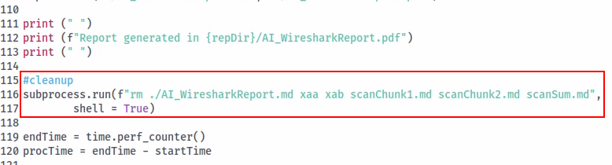

Spent a while fixing this error, troubleshooted and discovered token calculation line was looking for scansum.txt instead of scansum.md, thought that would fix it, I still get the error on subject files that are too long. These subject files are made by the team and have tens of thousands of packets, which is likely just crashing out ollama.
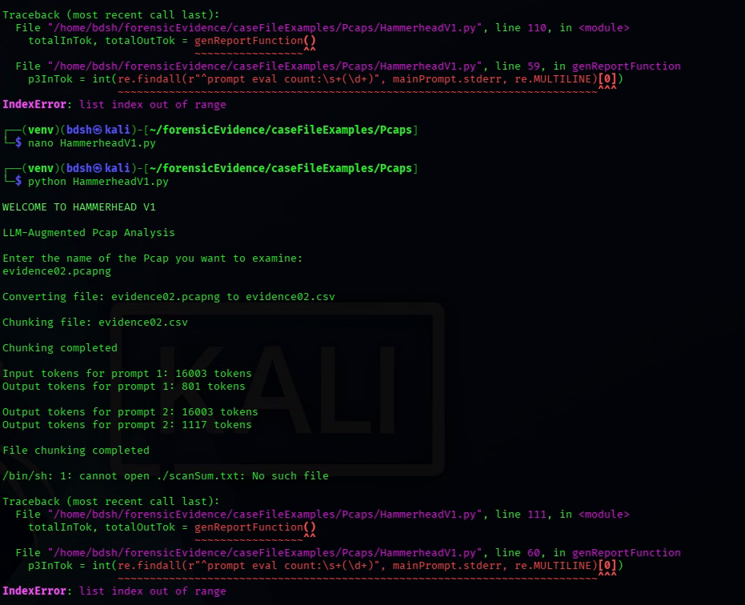
Also had the prompt display the packet range which appears to have worked.
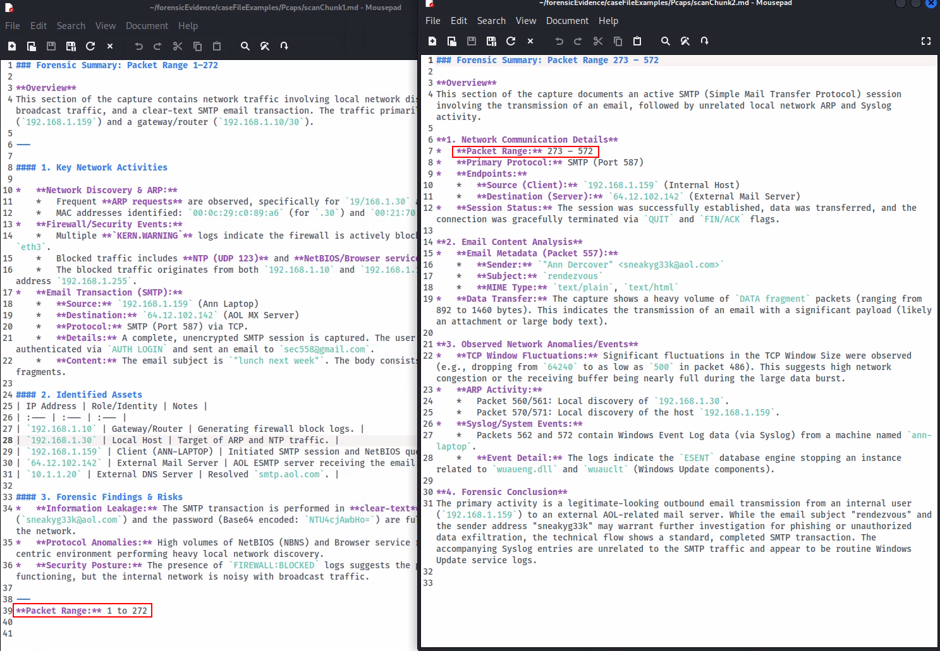

This is the exact amount this example pcap uses, so this confirms ollama is able to examine every packet, whenever a scan states its packet limit being less than that of the source pcap we will know it can not access the full context.
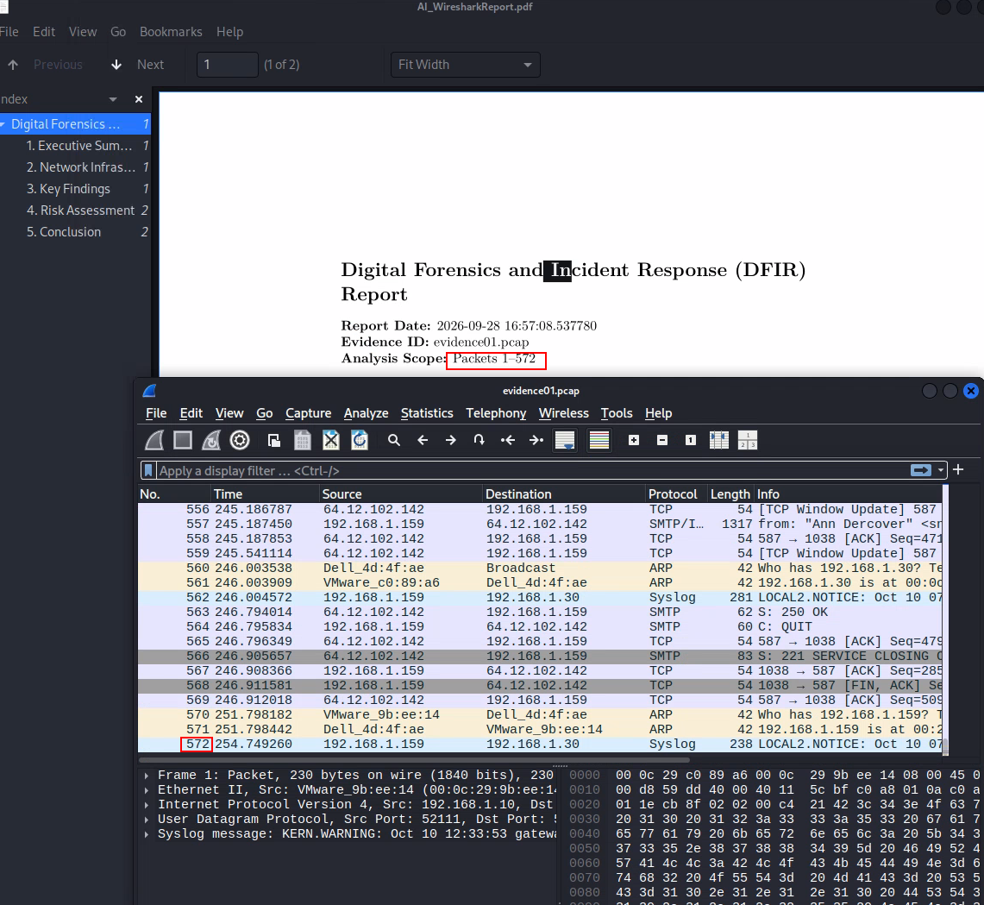

I then did multiple tests on evidence02 which is 7442 and while it does get through the whole file, it the first chunk consistently only counts from packet 10 – 3711 while the second does 7225 – 7442. This means I need to test chunking the file more.
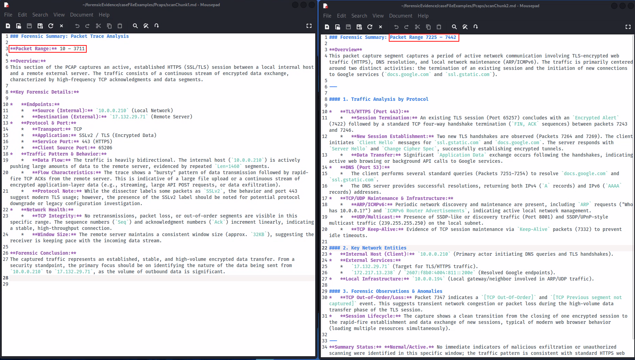
Tuesday, September 29
12:30 – 3:30 (3hrs)
Seeking to add XML > Token Oriented Object Notation (TOON) conversion to the nmap script, this is a fairly novel way of reducing token usage and making data more human readable by redacting “syntactic noise” like brackets and quotes present in json format.
https://github.com/AleLoredo/any2toon
I am using the any2toon python library to do this.
Any2toon install
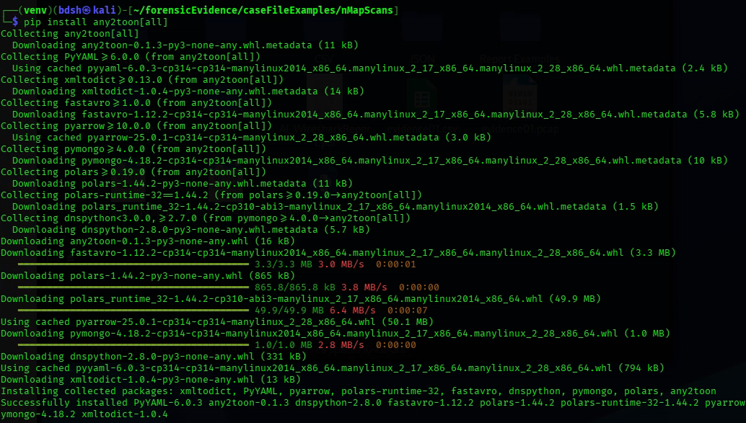
Attempting to figure out syntax to use any2toon in my script.
https://github.com/AleLoredo/any2toon
This is what I came up based on my knowledge and the any2toon documentation. But I got errors for and couldn’t get to work.
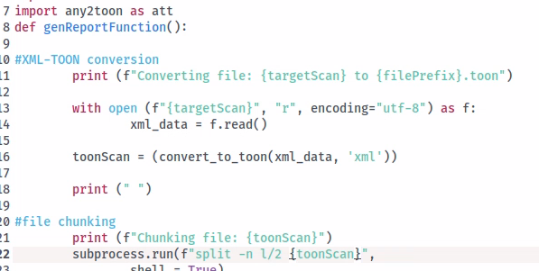
I decide to look for other options like toon-parse a command line converter, using this means I don’t need to deal with proprietary syntax to the degree of a python library.
Installing toon-parse
https://pypi.org/project/toon-parse/
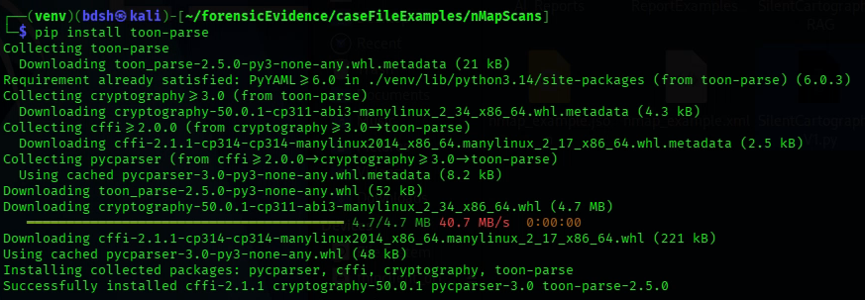
Wednesday, September 30
4:15 – 6:15 (2hrs)
Working on Nmap LLM integration script “SilentCartographerV1”
Added xml>toon conversion(1), substituted cat and pipe method of feeding files to directly feeding the files to the ollama prompt (2) (3)
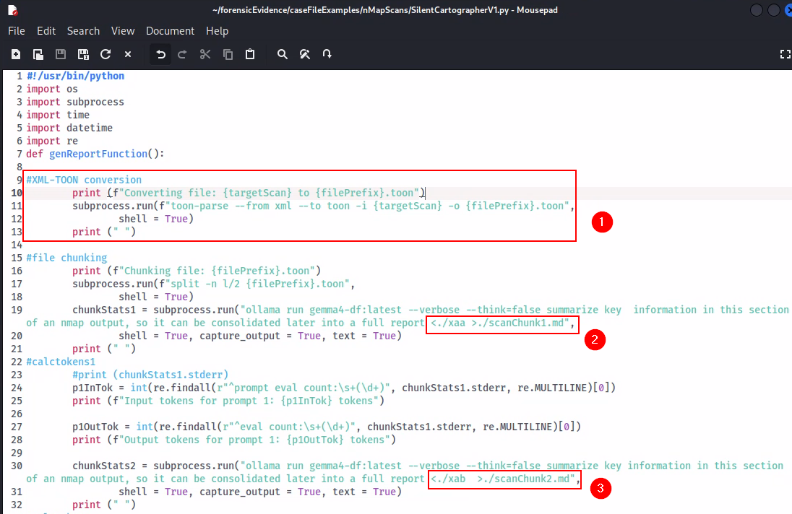
Added/modified inclusions similar to the hammerhead script, consolidated cleanup location, include deletion of all residual files, include timestamp of ai report and name of relevant nmap scan for reference by the AI. Modified the ollama call parameters to include –nowordwrap to prevent ANSI escape sequences, and modified the prompt itself to better fit the target output.
Ran A few tests with great results.
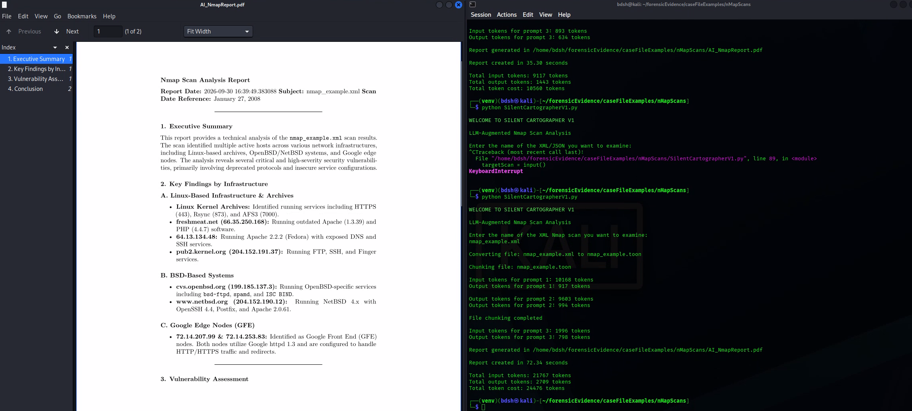
The datetime module produces a time that is correct but does not display the timezone and has too many decimal places, so I come up with a datetime line that satisfies both shortfalls.
Importing and using zoneinfo module which collects local times, and actually converts the given timezone (“Pacific/Auckland”) to the adjusted daylight savings time (+13) available on the system’s time zone database.
https://docs.python.org/3/library/zoneinfo.html
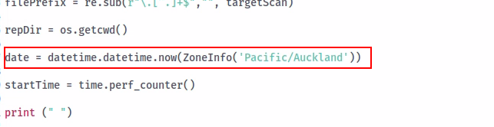
The resultant format is satisfactory
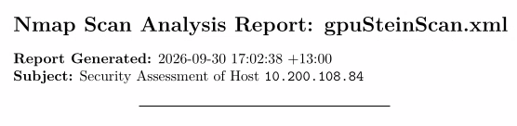

I modify my two other scripts (hammerheadv1 and ninemost) to use these datetime modules.
I then modify the Ninemost script to also output pdfs. Due to the new 30k context window, it is unnecessary to chunk the audit.txt, so I will remove the chunking stage. This means I also have to change the token calculation code and cleanup code.

Somewhat satisfactory Ninemost output, some text trails off the page (2) and the date is in 6 decimal places (1). However it’s much better than it was before. I like that it doesn’t get confused between the file carving timestamp and the given reporting timestamp.
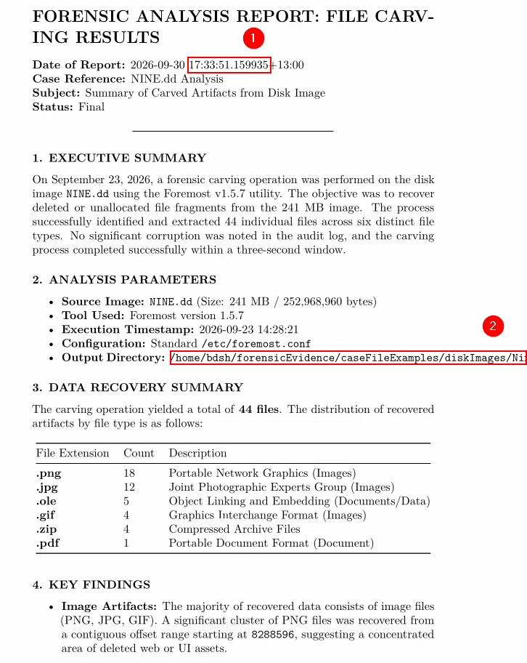

I created a new datetime module that uses the strftime method to format the date and time into the %c format for “Local version of date and time”
https://www.w3schools.com/python/python_datetime.asp
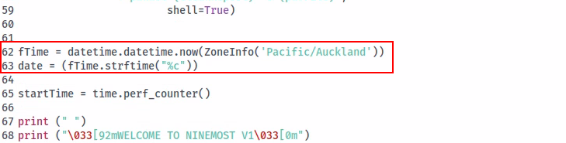
This date looks much nicer
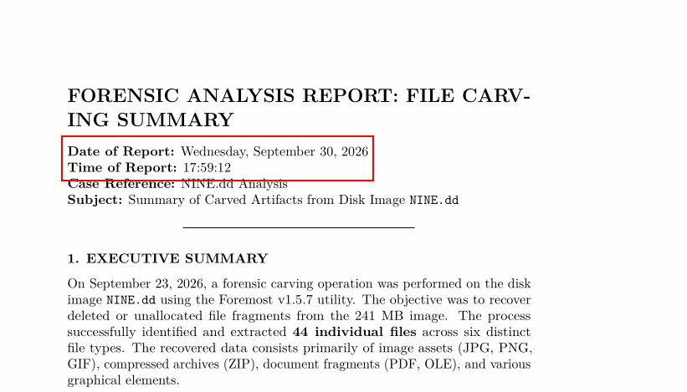
I add this module’s function to the rest of the scripts.

Friday, October 2nd
1:30 – 5:00PM (4hours 30 min)
Using my newly updated scripts with the new 30k context window to generate official reports for our 3 case files and 3 tools. Inspecting the outputs for errors/inconsistencies. Migrating these to the official git folder for reports for comparison.
First I produce the reports for the Foremost output using my NinemostV1.py script.
Producing report on EIGHT.dd, took 37 seconds, 2711 total tokens.
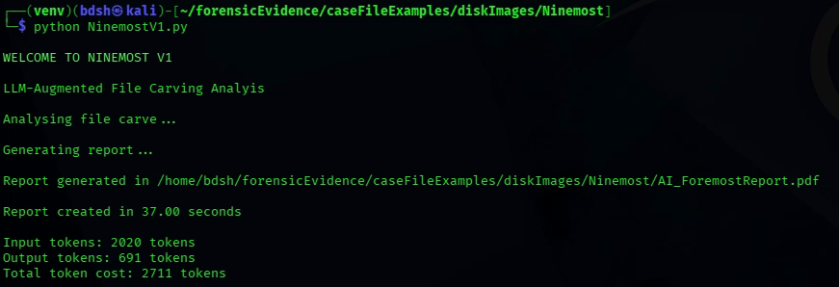
Report itself on EIGHT.dd
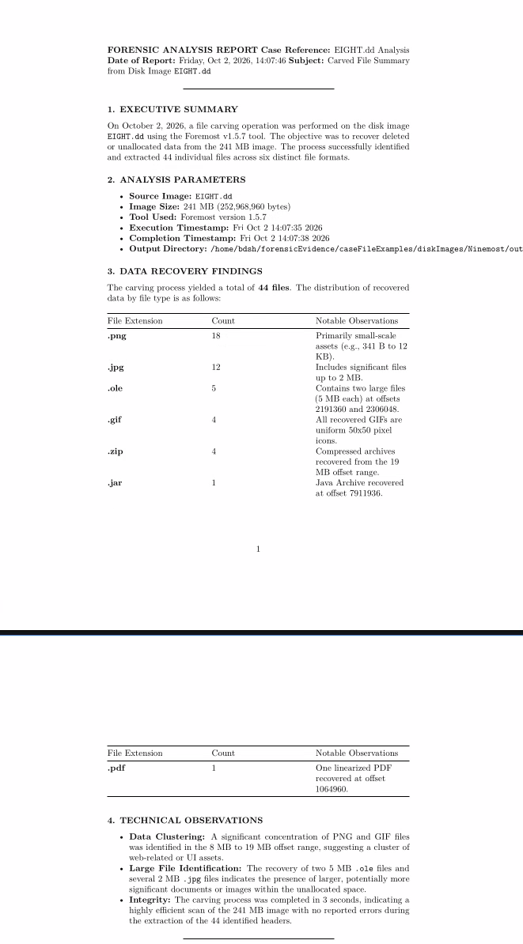
Producing report on Three.dd, took 44.06 seconds, 2201 total tokens.
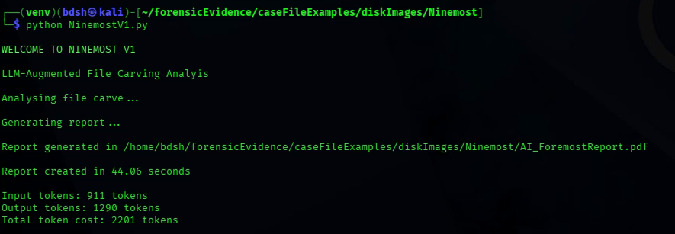
Report itself on Three.dd
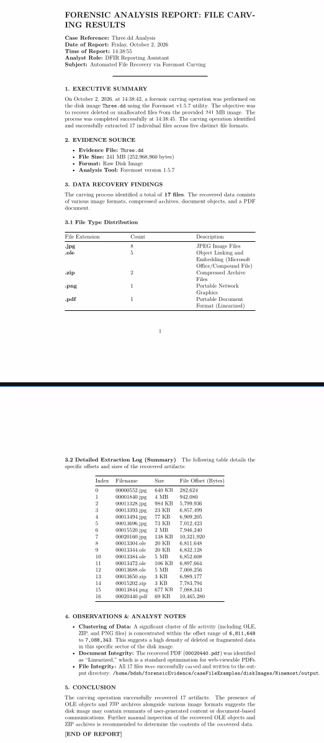

Producing report on NINE.dd, took 35.91 seconds, 2707 total tokens.
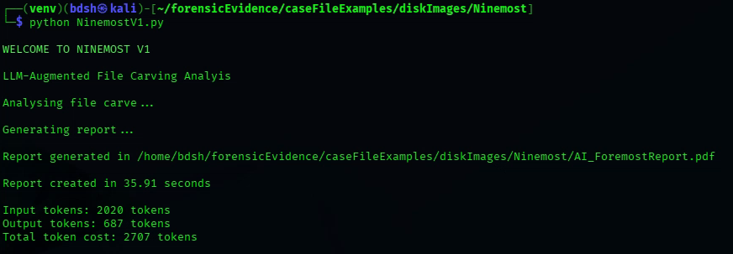
Report itself on NINE.dd
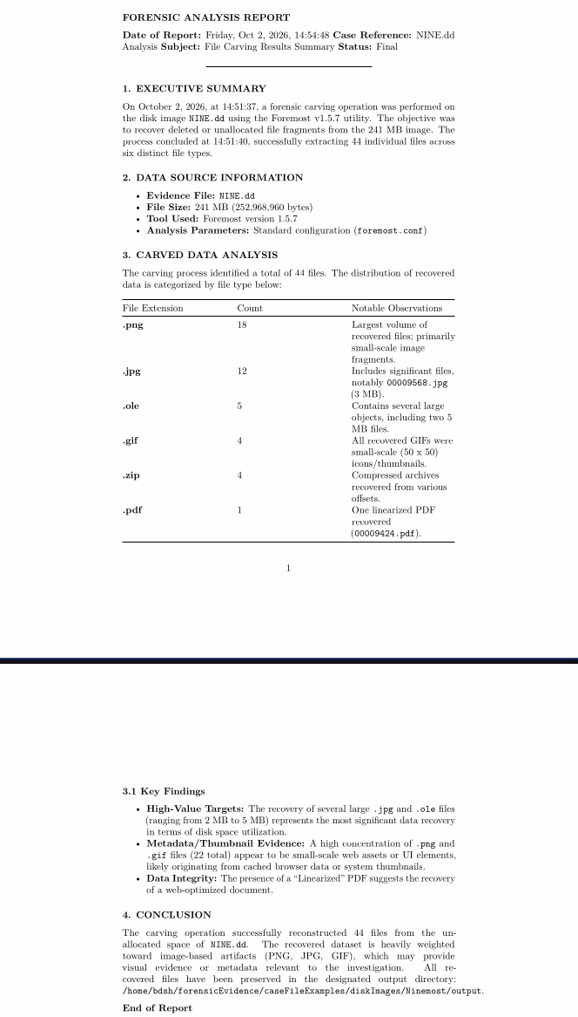

Then I began producing reports for Wireshark packet capture (pcap) files, using my script HammerheadV1.py.
Producing report on evidence01.pcap, took 106.35 seconds, 57943 total tokens.
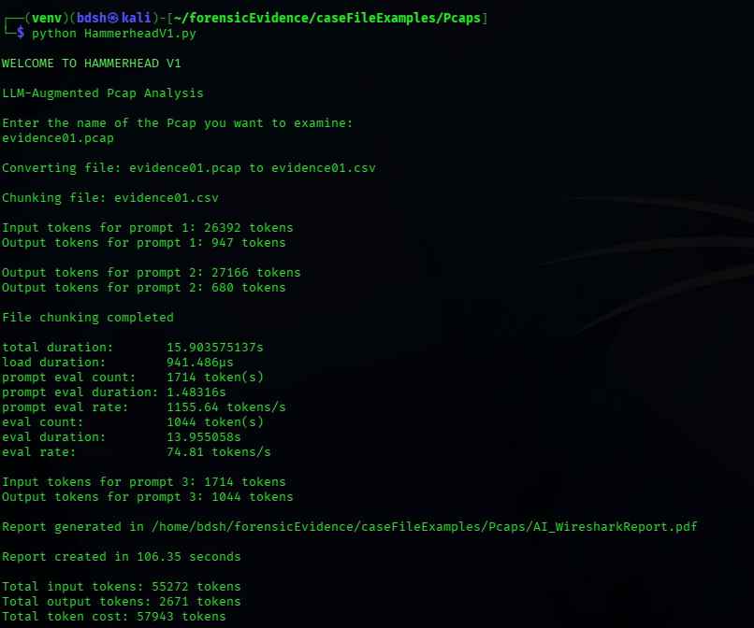
Report itself on evidence01.pcap
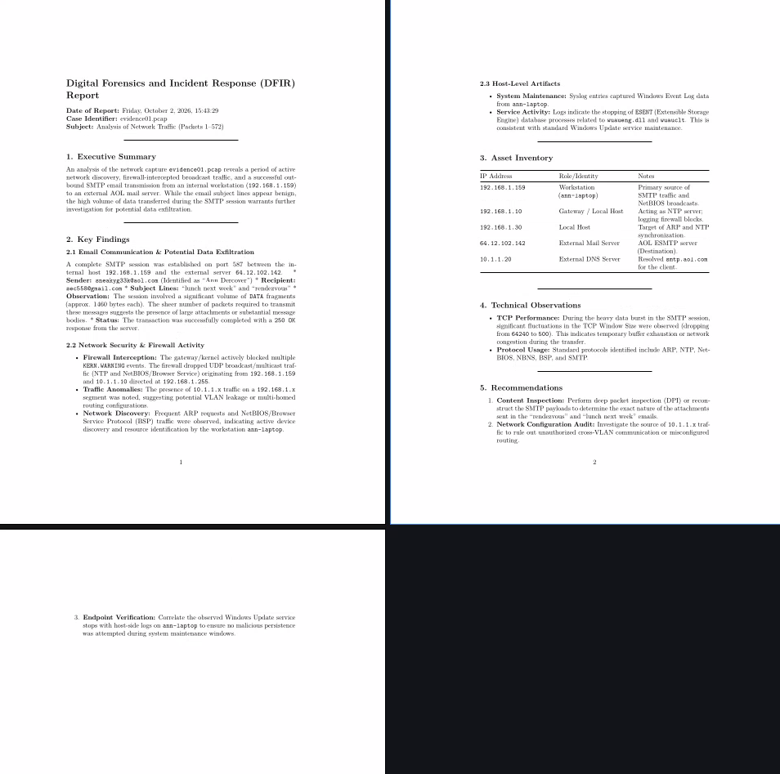
Producing report on evidence02.pcapng, took 62.10 seconds, cost 36288 tokens total.
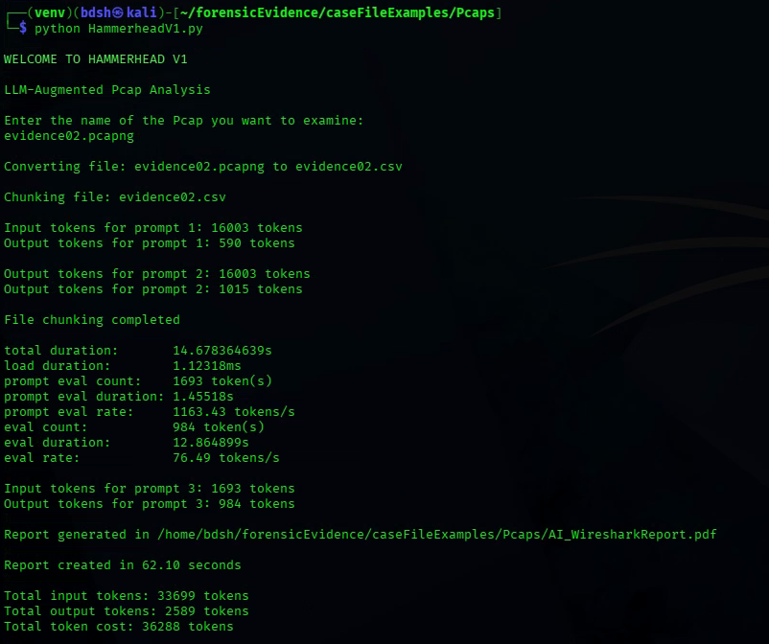
Report itself on evidence02.pcapng
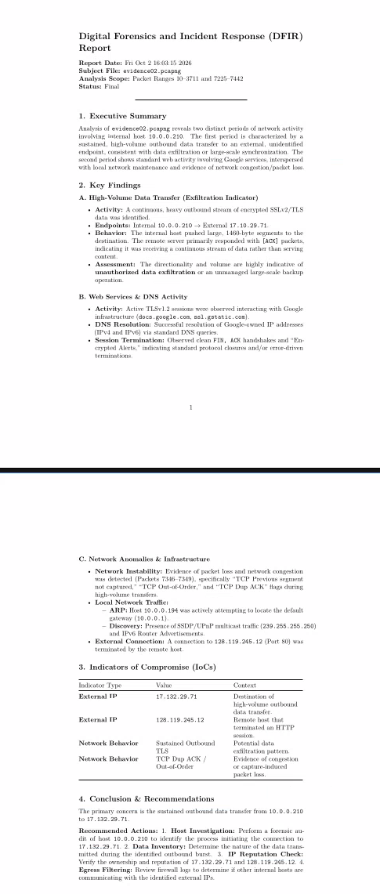
Producing report on evidence03.pcap, took 59.54 seconds, cost 35956 tokens total.
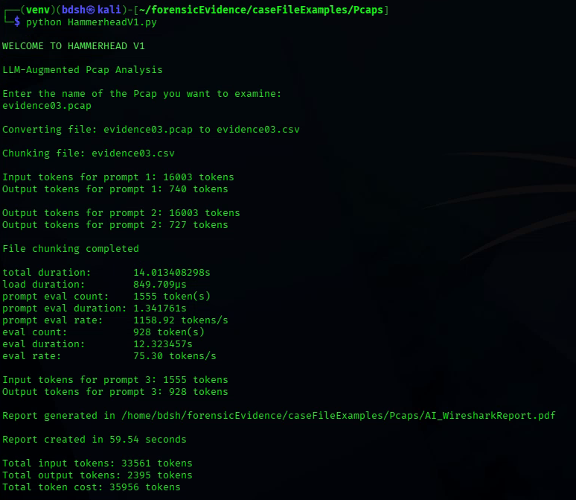
Report itself on evidence03.pcap
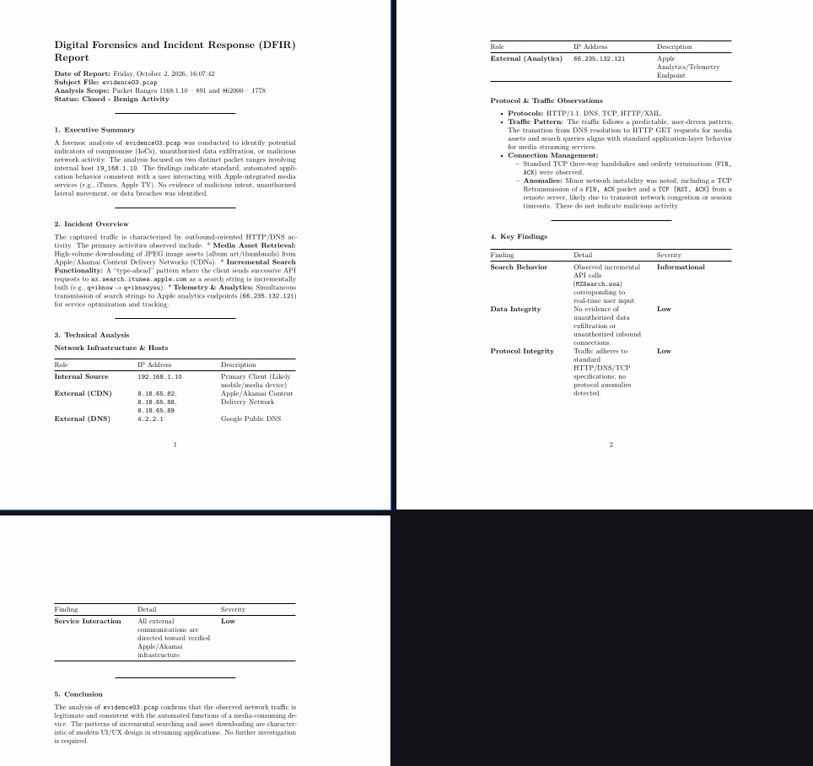
Then I began producing reports for the Nmap scan (xml) files, using my script SilentCartographerV1.py.
Producing report on nmap_example.xml, took 75.87 seconds, cost 24251 tokens total.
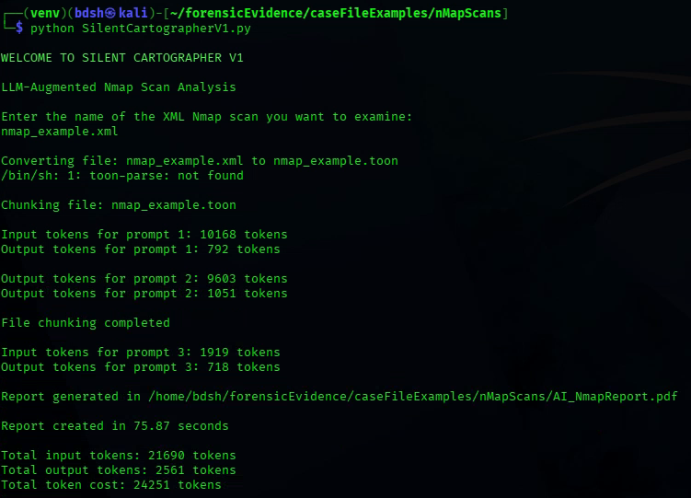
Report itself on nmap_example.xml
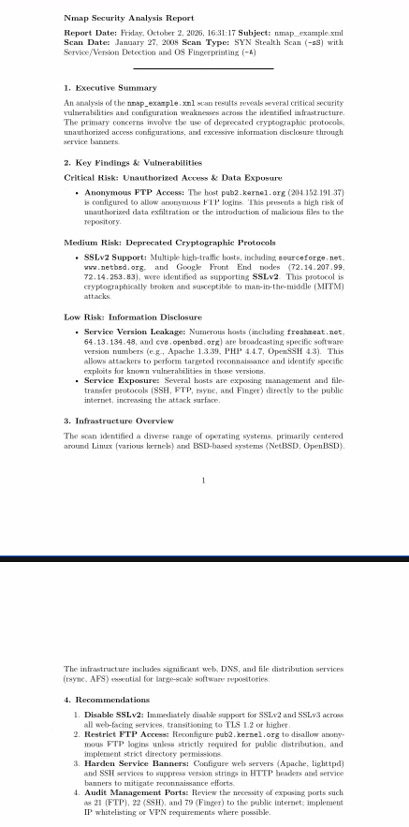
Producing report on SOITnetworkscan.xml, took 38.33 seconds, cost 19933 tokens total.
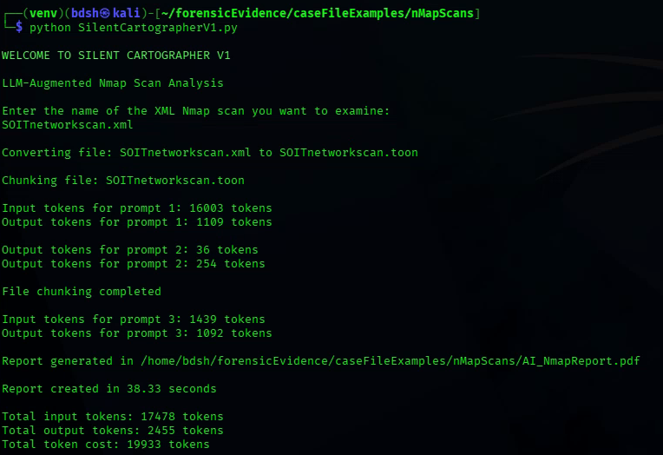
Report itself on nmap_example.xml
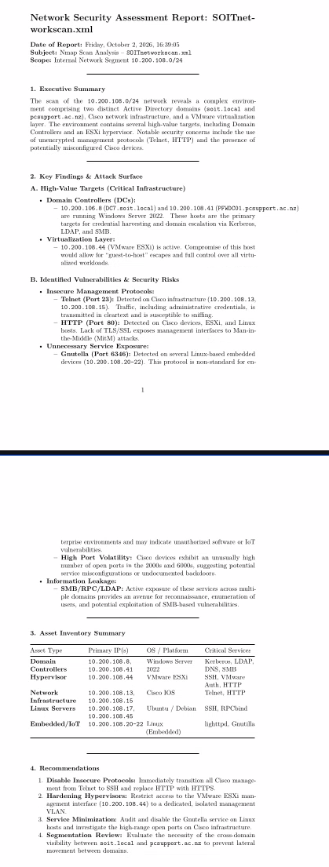
Producing report on 28sepServiceScan.xml, took 59.48 seconds, cost 34716 tokens total.
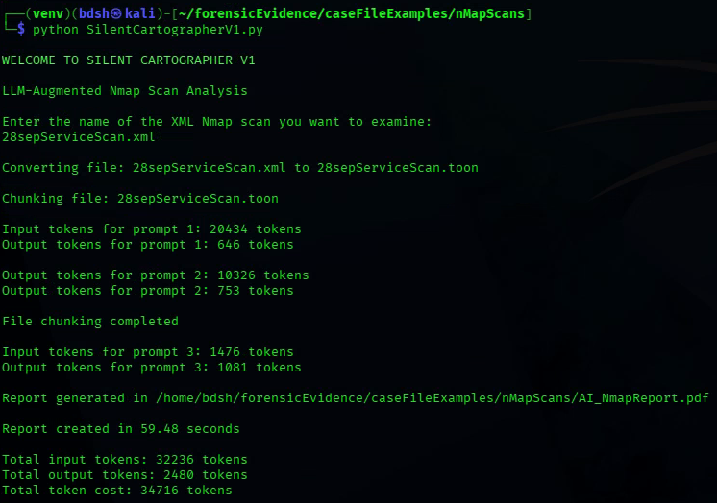
Report itself on 28sepServiceScan.xml
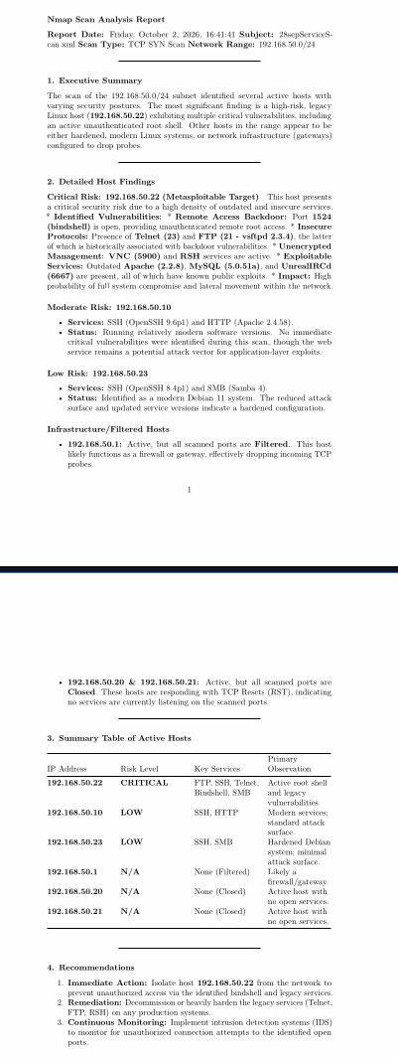
I then marked down the relevant information about the investigation into the forensic file tracking document and migrated the reports to the git.

